These instructions show you how to install and configure the AWS VPN client to connect to the AWS EC2 Linux instance provided to you.  
  
What you’ll need:

* A system running either Windows, MacOS, or Ubuntu Linux
* The VPN client and configuration files (ovpn, certificate and key files)
* The IP address and SSH key of your AWS EC2 instance

1. Create the folder to copy the VPN config file into.   
   You should use the folder name and location shown below according to your Operating System, or else you will have to edit a configuration file later on with the name of the folder you created.

| **Folder Name (Linux)** | **Folder Name (Windows)** | **Folder Name ( MAC)** |
| --- | --- | --- |
| /home/(name)/hfg-vpn | c:\Users\(name)\hfg-vpn | /Users/(name)/hfg-vpn |

Windows and Mac

Use your OS native file manager to create the folder. Please note that you must replace “(name)” with the name of your own home directory.  
  
Linux  
eg.

| $ sudo mkdir ~/hfg-vpn |
| --- |

1. Download the **VPN configuration file**, **Certificate File** and **Key file** that was provided to you into the folder you created in the step above.  
     
   Windows and Mac  
     
   Use your OS native file manager to view the folder. For example  
   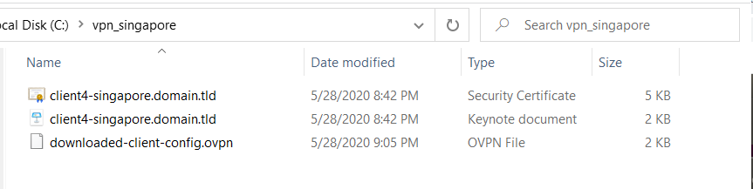  
     
     
   Ubuntu Linux  
   e.g  
   
2. Open the file respective to your operating system; use the “...mac.ovpn” for mac, “...windows.ovpn” file for windows, “...linux.ovpn” for linux. Open these files with any text editor (notepad works for windows, textedit works for mac), and update the final 2 lines to the folder location from step 2



1. Download the VPN client appropriate for your Operating System .  
     
   Download using the appropriate link

| Operating System | Link |
| --- | --- |
| Windows | <https://aws.amazon.com/vpn/client-vpn-download/> |
| Apple Mac | <https://aws.amazon.com/vpn/client-vpn-download/> |
| Linux Ubuntu (18.04) | <https://docs.aws.amazon.com/vpn/latest/clientvpn-user/client-vpn-connect-linux.html#client-vpn-connect-linux-install> |

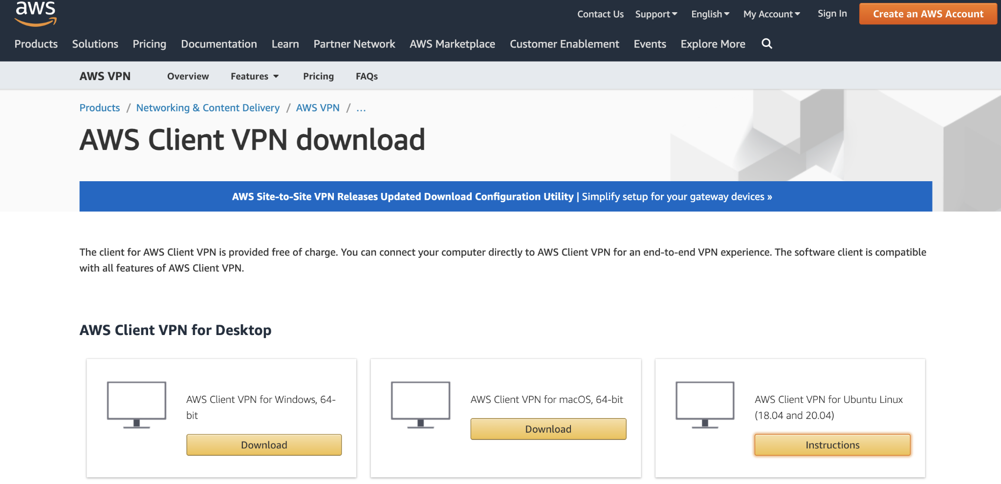

1. Install the VPN Client   
   Follow the instructions below for your Operating System  
     
   Windows  
   Execute the installation binary you downloaded  
     
   Clieck **Next** -> **I Agree** -> **Next** (to install) -> **Close**  
     
   Mac  
   Use the OS native App manager to install the client  
     
   Linux (from terminal)

| wget -q -O - https://d20adtppz83p9s.cloudfront.net/GTK/latest/debian-repo/awsvpnclient_public_key.asc | sudo apt-key add - |
| --- |

* 1. Depending on your Version:
     1. Ubuntu 18.04:

| echo "deb [arch=amd64] https://d20adtppz83p9s.cloudfront.net/GTK/latest/debian-repo ubuntu-18.04 main" | sudo tee /etc/apt/sources.list.d/aws-vpn-client.list |
| --- |

* + 1. Ubuntu 20.04:

| echo "deb [arch=amd64] https://d20adtppz83p9s.cloudfront.net/GTK/latest/debian-repo ubuntu-20.04 main" | sudo tee /etc/apt/sources.list.d/aws-vpn-client.list |
| --- |

| sudo apt-get update |
| --- |

| sudo apt-get install awsvpnclient |
| --- |

1. Run the VPN client   
     
   Windows  
   from the Desktop icon or from the Start menu   
   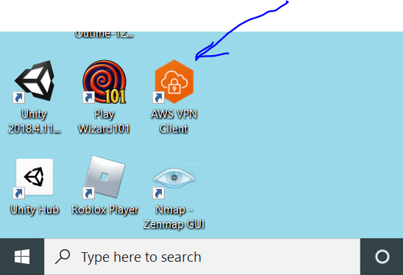  
     
   Mac  
   Open the AWS VPN Client app  
     
   Ubuntu Linux  
   This step is not required on Linux
2. Create a Profile for the VPN configuration you received.   
     
   This step is the same for Windows or Mac. It’s not required on Ubuntu Linux  
   Windows screen shots  
   **File - > Manage Profiles -> Add Profile**  
     
   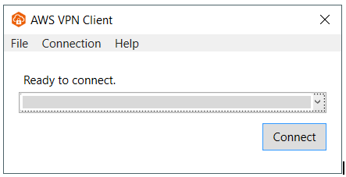  
     
   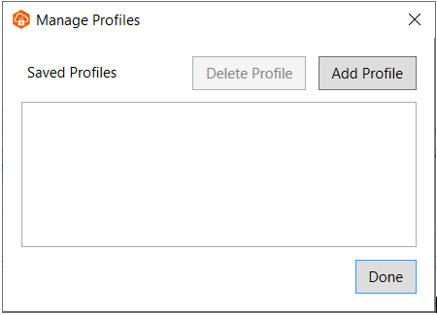  
     
   Enter a name for the profile and select the .ovpn Configuration File (the one you edited before  
   then **Add Profile**  
   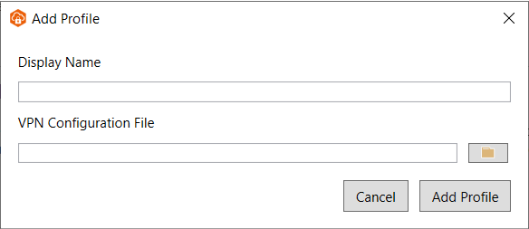  
     
   Mac Screen Shots  
     
     
   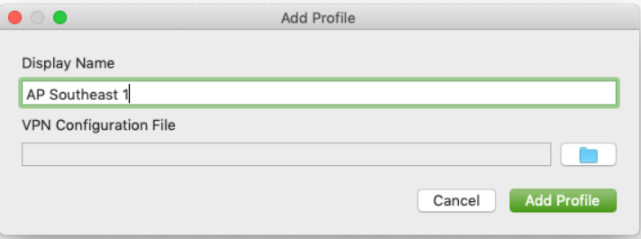
3. Establish the Connection to the VPN  
     
   Windows & Mac  
     
   Select the profile and Click **Connect**  
   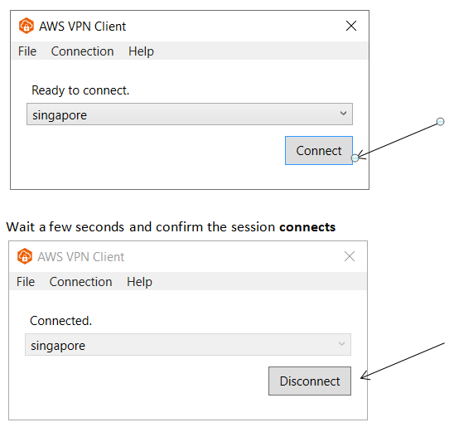  
   At this point the VPN connection is established and you can proceed to SSH into your AWS Linux system
4. Connecting to your EC2 Linux instance via SSH  
     
   Windows  
   Use Putty to connect to the AWS Linux host. See [these](https://www.ssh.com/ssh/putty/windows/) instructions for reference Use the host **ssh key** provided to you.  
     
   Mac and Ubuntu Linux  
   Use the OS native ssh client to connect to the AWS Linux hosts. Use the host **ssh key** provided to you.

SSH Syntax:

| $ ssh -i <key_name> force@<host_ip_address> |
| --- |

eg.  
